Design - Activity Diagrams

Add Project Title

Version: 1.0

By

Add Name

Supervised by

Add Supervisors

Networked Appliances Lab
School of Computing and Mathematical Sciences
Liverpool John Moores University

Table of Contents
Table of Contents ii
Table of Figures iii
1 Activity Diagram: Start Device 1
1.1 Description 1
1.2 Issues 1
1.3 Requirements 2
1.4 Goals/Context 2
1.5 Assumptions 3
1.6 Scenario/Steps 4
1.7 Extensions 4
2 References 6

Table of Figures
Figure 1 Start Device 1

Activity Diagram: Start Device

Description
This Activity Diagram illustrates what happens when the device is initially started within this framework. The Activity Diagram is illustrated in Figure 1.
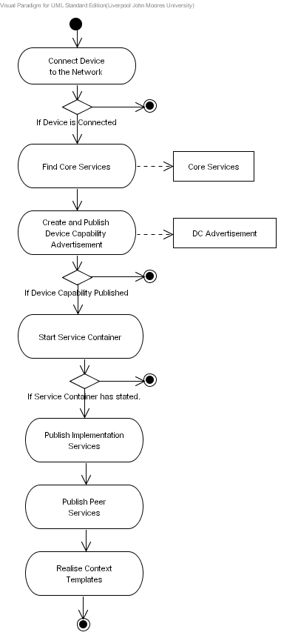
Figure 1 Start Device

Issues
The issues associated with the Activity Diagram are not known at this stage.

Requirements
When a device is switched on it must connect itself to the P2P network – if the device is unable to connect then the boot sequence must terminate and the device must remain in a non-operational state. If the device successfully connects to the network it must discover all the required core Peer Services and bind to them. These services may reside locally or remotely within the P2P network. For each core Peer Service that is discovered a core service object must be created.
Once all the core services have been discovered and bound to the device must create a Device Capability Advertisement, which must describe the hardware, software and networking capabilities the device supports. Within this function mechanisms must be implemented that allow the device to reflect on its internal capabilities, which must be described in the Device Capability Advertisement. If the device fails to determine the capabilities it supports then the device must remain in a non-operational state. The Device Capability Advertisement must be serialised as an advertisement and published locally and remotely within the P2P network. When the advertisement has been published the implementation services used to bind to each Peer Service the device provides must be created. For each implementation service created, it must be published in the service implementation container – this function is dependent on the service technology being used. Each implementation service used by the device must result in an implementation service object. Using implementation services within this framework is not mandatory and is only designed to form a level of abstraction that allows different service technologies to be used.
If the device manufacturer choices not to use implementation services then the service logic must be placed within a Peer Service. In this instance the device will create and publish each application specific peer service the device uses. Again this results in an application specific Peer Service object being created for each application specific Peer Service used by the device.
The final stage requires the device to retrieve the Context Templates it has that describes how the device and its services can be used. Context Templates guide the composition of services and for each service used in a context an application specific Peer Service must be created, if it doesn’t already exist.

Goals/Context
Within this Activity Diagram there are a number of goals that need to be addressed, which are described below.
- Connect Device to the network: When the device is initially switched on it must be connected to the network before it can publish and discover services. If the device cannot connect to the network then it must remain non-operational until the network connectivity error has been rectified – in this instance the device will not be able to publish, discover or use any Peer Services.
- Find Core Services: Devices are required to discover and bind to core services before they can effectively operate within the P2P network. The device may choice to implement some, all or none of these services. Services that are explicitly implemented by the device can be directly used and services that are not explicitly implemented must be discovered remotely and bounded to within the P2P network.
- Create and Publish Device Capability Advertisement: Each device must advertise the capabilities it supports, such as hardware, software and networking capabilities. This must result in a Device Capability Advertisement. If the device fails to successfully advertise it capabilities then an assessment of how effective it can execute the services it provides cannot be determined. Consequently the device must remain non-operation until the error has been rectified.
- Create and Publish Implementation Services: Devices may use implementation services that reside either locally on the device itself or remotely within the P2P network. The type of services used by devices may differ and within this framework they can co-exist – for example Web Services, RMI and CORBA services can be used simultaneously. These services are abstracted away using bindings to generic peer services, which provide a level of flexibility that allows implementation services to be changed to integrate legacy and new service specifications as and when they emerge. If implementation services are used the device must loop through each service and publish it within the service container. In this instance how a service is published is dependent on the service technology being used. Device manufacturers may choice not to support implementation services and in this instance the service logic must be placed in an application specific Peer Service.
- Create and Publish Peer Services: Peer Services provide a generic interface that allow implementation services to be invoked (if implementation services are used – if they are not used then the methods within the Peer Service must be invoked). The device must loop through each peer service used by the device and create a Peer Service object. Once the Peer Service objects have been created they must be published locally and remotely within the P2P network. Devices may choose not to provide implementation or Peer Services but rather they may just wish to use services within the network – because of its limited resources it may not be capable of providing any services. In this instance the device will not create or publish any application specific Peer Services of its own.
- Realise Context Templates: Devices may be used in numerous contexts, which require several other services before they can effectively work. For example a DVD player cannot be used on its own – it requires audio speakers and a visual display. A DVD player that works in this context may be described as a Home Entertainment Theatre System. Consequently a device will have zero or more contexts that describe how the device may be used and what services are required to realise that context. As such the device must discover all the required application specific Peer Services needed within a particular Context Template. This must result in several application specific Peer Service objects, which are explicitly bound to the semantic hooks that exist within the Context Template.

Assumptions
The assumption within this Activity Diagram is that Public Key infrastructures and Digital Certificates are used for authentication and data encryption and decryption. However the framework provides generic interfaces that allow any security model to be overridden and implemented by device manufacturers.

Scenario/Steps
When the device is switched on it must execute a bootstrap routine that connects it to the P2P network. When this routine connects the device to the network it returns a Boolean value indicating the connection status. If the device fails to connect then the bootstrap routine will exit and the device will remain in a non-operation state until the error is rectified. If the device is successfully connected the device calls a routine to create and publish the Device Capability Advertisement. If the device advertisement is successfully create, this results in a Device Capability Advertisement object. This object is serialised and distributed locally and remotely within the P2P network. If this object cannot be created or the advertisement cannot be published the bootstrap routine must exit and the device must remain in a non-operation state until the error is rectified – devices can only participate if the capabilities they provide have been published. This allows other devices to determine whether the device is capable enough to execute the services it provides. Furthermore it allows devices to select services from devices that are the most capable, which ensures that the highest quality of service is maintained.
When the device has published its capabilities a routine must be executed that allows all the implementation services used by the device to be created and published. The device will load a descriptor file that lists all the implementation services – the device will iterate through this list and create and publish each implementation service it discovers. If no implementation services are used the device must exit this routine and execute a routine to create and publish the Peer Services used by the device. Again the device will load a descriptor file that describes all the Peer Services used by the device, which also describes how the Peer Service is bound to its associated implementation service – this only applies if the device uses implementation services, if not then no binding will be required as the logic will be in the Peer Service itself.
The device must also execute a routine to discover all the required core services used within the framework. The device will try to discover the services locally within its service advertisement cache or remotely within the P2P network. If the core service is implemented by the device the relevant core service object will be created. If the core service is not explicitly implemented by the device then a remote service must be discovered within the P2P network and bound to.
When all the core services have been discovered and bound to the device must execute a method that allows all the required application specific Peer Services to be discovered and bound to all the semantic hooks defined in the Context Templates the device supports. If a Context Template has all its semantic hooks bound then the it must be marked as enabled – this means that all the required services needed to execute the Context Template have been discovered.

Extensions
This framework provides a level of flexibility that allows Peer Services to form an abstraction that maps to any implementation service technology the device manufacturer or organisation uses. However there may be instances whereby only the Peer Service can be used. For example such service technologies as Web Services and RMI are transactional and although this may not pose a problem in some situations it may in others – one example may be streaming large amounts of video and audio data. In this instance the action is not transactional – data streams need to be opened and maintained whilst the data is being transferred or broadcasted. Therefore it may be easier to stream the data directly to a Peer Service without using a secondary implementation service. This scenario is not set in concrete and device manufacturers may decide to stream data to an implementation service via a Peer Service in order to maintain the level of abstraction.
Provisions need to be made that describes how the Context Templates are managed. It is highly likely that services will unexpectedly become unavailable for a variety of reasons, the most obvious being the device disconnects from the P2P network, taking all the services it provides with it.

References

